Class of 2010 Representative Elections, Paper Ballot
Please fill out this form completely.

Your name: NetID (if applicable):
Email Address:

You may choice up to 5 candidates below, or write in candidates:
1.
2.
3.
4.
5.

Candidates (Total: 14)


1. Yigiter Izgordu

“Yig is your man, for your plan”

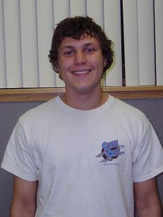

2. Kevin Kobilinski

“FTW”

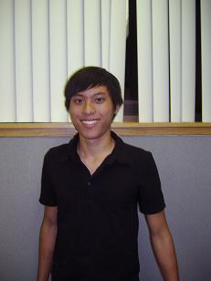
3. David Chin

“Where's your chin? Put your chin on the EGC! Vote David Chin for 2010 Rep!

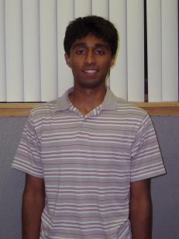

4. Adarsh Dasika

“What can Brown do for you?”


5. Stephanie C. Loh

“Get Results When You Get Loh!”

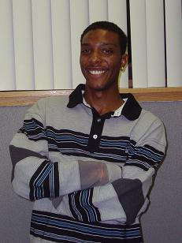
6. William Carrington

“Get Results When You Get Loh!”

7. Vamsi Kodamasimham

(No photo available)



8. Thomas Neubauer

“Vote for new, vote for power, vote for Tom Neubauer”

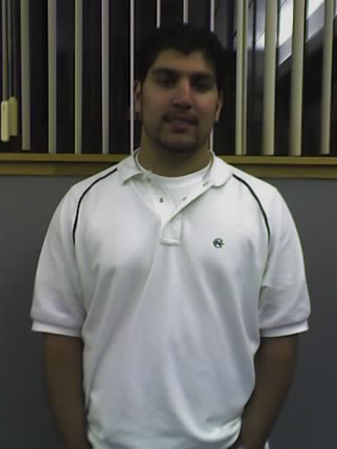

9. Murtaza Naqvi

“Trust me! I know Usker!”

10. Christopher Doe
(No photo available)
“Engineering a better future for Engineers”

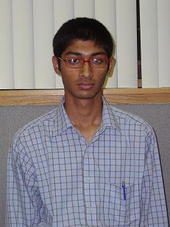

11. Nikhil Kasthurirangan

“I sit for engineers instead of stand”

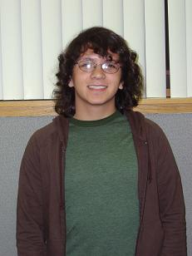

12. Michael Doyle

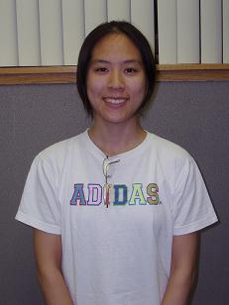

13. Ayaka Koshibe

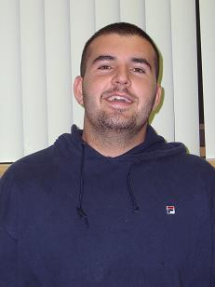

14. Alex Krunev

“Conquering America, one fat sandwich at a time”

